# Pacu Jawi – Bull Racing

Pacu Jawi is an Indonesian based sport where villages compete in an intense race which requires a jockey to ride two bulls across a rice field.

## History

The sport was first founded in Tanah Datar, a region in West Sumatra, Indonesia. In tradition of the Minangkabau (Minang) people, the races were held on Mount Marapi, 2,891 meters tall. This location was thriving in agriculture, with the majority of farmland dedicated to rice fields. The sport would take place after the rice fields have been harvested as to rejuvenate the fields before the next planting phase and was also a form entertainment and celebration for the villagers. Pacu Jawi is hosted by different districts inside Tanah Datar: Sungai Tarab, Pariangan, Lima Kaum and Rambatan. The sport began centuries ago, predating the Indonesian Independence, previously, it was held only twice a year but following the shortening of the harvest cycle, the celebration can take place more frequently. By 2013, one of the districts hosts the event every two months, with each instance consisting of four events on Wednesday and Saturdays.

## The Race

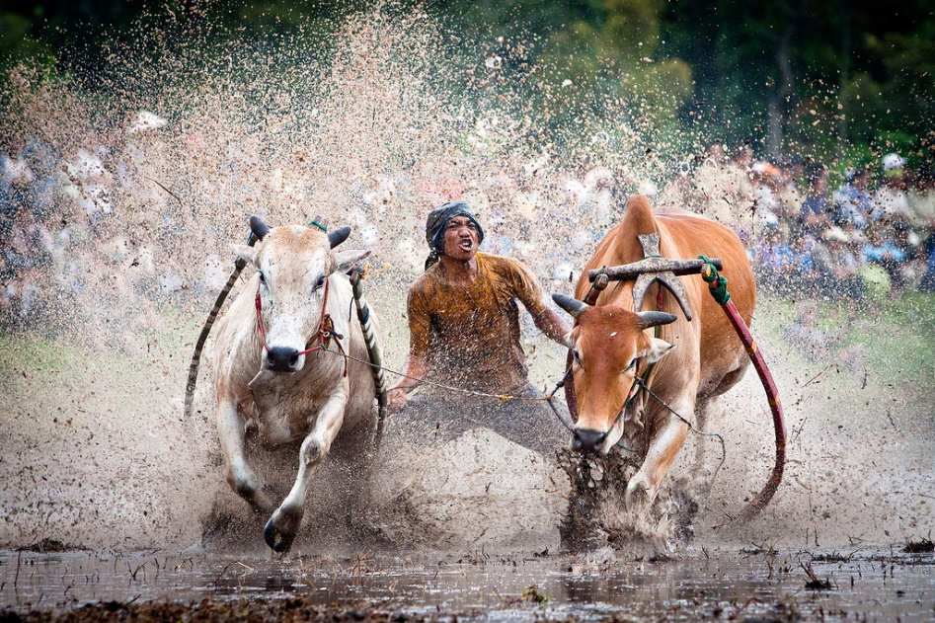Although Pacu Jawi includes the word ‘racing’, there is no direct competition between the bulls or jockeys. The rider would race across the track with two male bulls connected by rope to a wooden plough, which is where the jockey stands. With the changing nature of the rice fields, some tracks can vary from 60m to 250m long covered in 12” of mud. The bulls are trained to an extent to remain stationary until someone steps onto the plough. The jockey must remain in control of the bulls whilst struggling to stay on the plough whilst it’s in motion. Due to the bulls unexpected behaviour, the jockeys can bite their tails to regain control over them and to provide speed boosts for the jockey. The spectators judge the bulls by their strength, speed and ability to race in a near straight line. Showing these abilities are meant to teach people that those who follow the straight path deserve the most respect and honour.

Sources: <http://ohmag.la/en/oh-mag/travel-adventure/item/426-pacu-jawi-%E2%80%93-racing-bulls-in-west-sumatra.html>

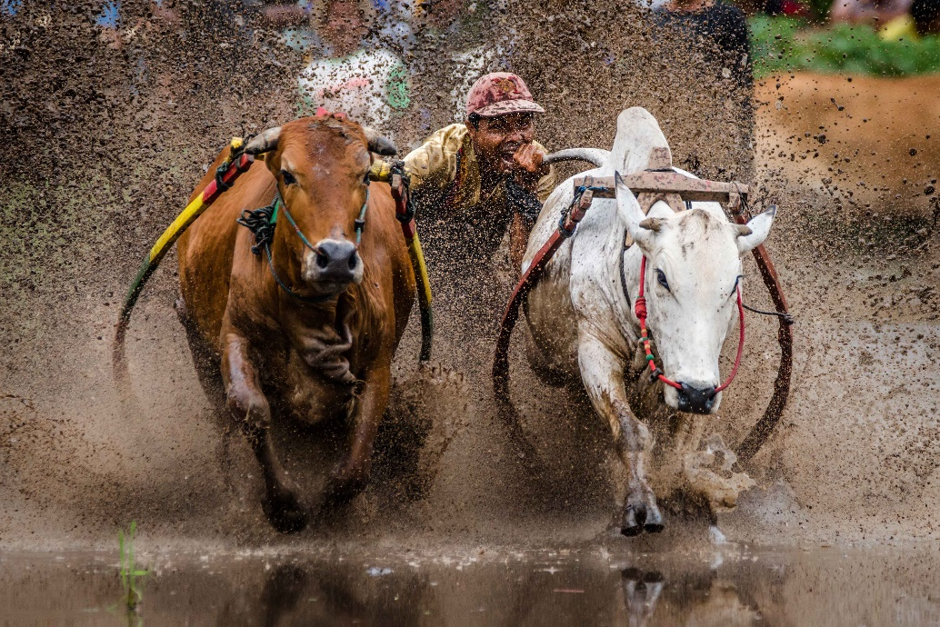

# Caber Tossing

Caber Tossing is a Scottish based sport where the user tosses a caber into the air in hopes of it spinning 360 degrees and lands in the 12 o’clock position to the thrower.

## History

The sport originated in the Scottish Highlands. The caber was used during military campaigns where large beams were tossed over wide ice streams to provide a temporary bridge for soldiers. The first record of an athletic caber toss was 1574, with its history deep in military roots, the toss is graded according to accuracy rather than distance from the thrower. The aim is to throw a caber, usually 19.5 ft in length, in such a way that it turns end over end and lands away from the thrower in a straight line. Caber tossing didn’t become a true sport until after the years of WW1. During the war, American soldiers would utilise the Scottish technique for crossing enemy trenches to avoid traps.

## The Highland Games

Afterwards, Scotland established their own games event, known as the Highland Games, established in the 1820’s. The Highland Games ran from May to the end of September, with caber tossing one of the main attractions. The tosser balances the caber upright with the tossers interlocked hands at the base of the caber. They would run a short distance to gain forward momentum and flips the base upwards so that the opposite ends hit the ground first. To get the perfect toss, the caber must fall in line directly with the tosser. Weight and strength are essential for a successful toss, but technique is also required for balancing the caber correctly before tossing it. The winner is decided by the straightest end-to-end toss.

Sources: <https://theculturetrip.com/europe/united-kingdom/scotland/articles/tossing-the-caber-what-exactly-is-it/>

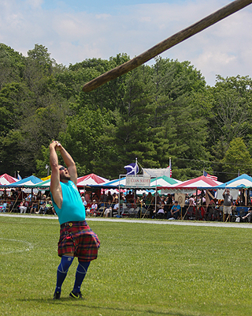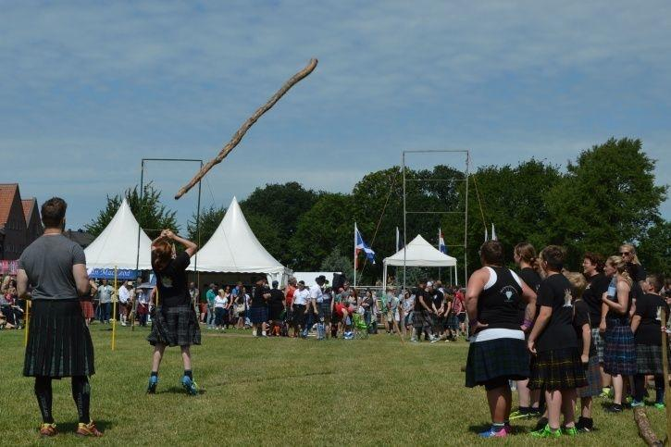

# Tuna Tossing

Tuns tossing is an Australian sport where participants must toss a tuna as far as possible.

## History

In 1979, in a small fishing community in Port Lincoln. Fishermen would throw tuna into trucks after docking to the bay. The fishermen enjoyed throwing tuna so much they decided to turn it into a small challenge between themselves to see who could throw it the furthest. During this period, money was tight for the villagers in Port Lincoln and many would look for any form of job to help keep them afloat. A couple guys passed by the fishermen and saw them throw tuna into trucks parked far from them. This game them the opportunity to ask the fishermen what they were doing. This was the first time they introduced the challenge to someone that wasn’t a fisherman. They challenged the boy to throw the tuna as far as they could, and they would pay them. The boy obliged and launched the tuna into the air. The fishermen were surprised to see how far a threw a heavy fish. They paid him but he was eager to come back the next day. Many local lads would line up in those uncertain economic times, looking for a few hours paid work. They had to pass a simple test. Throwing a fish as far as they could, or at least as far as was needed on the day, depending on tide and truck. The best throwers would get the work for the day. It was a prideful thing, a boast for the boys afterwards, as they spent part of their earnings at the nearest hotel to quench their hard-earned thirst. Men being men, this had become a local bragging right, to see how many days work they gained, or how far their fish flew.

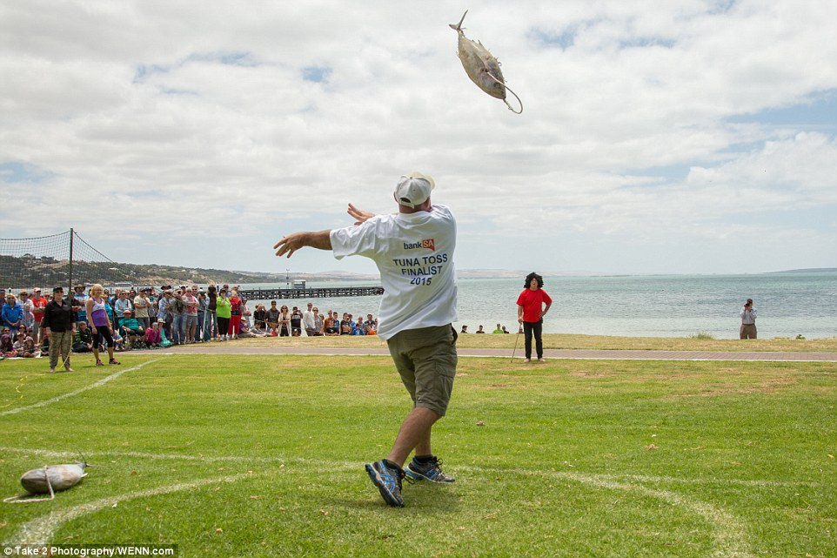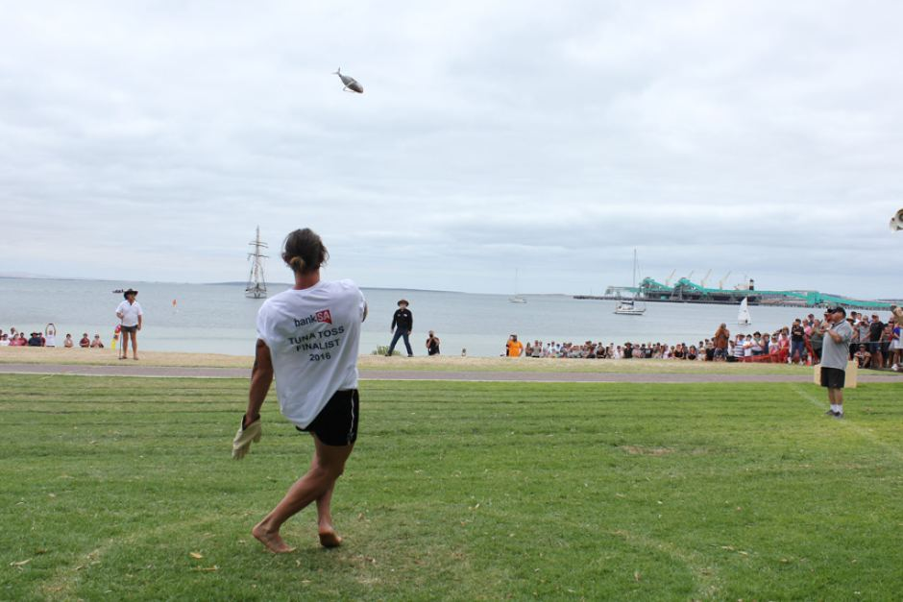Sources: <https://www.tunarama.net/article-heading/>